

# Instructions for Pairing Whisper Lift II PRO Remote to Control Box

1. Using a paper clip, press and hold the RED button on the back of the remote control until RED LED light on the front of remote control flickers. Once the RED LED light flickers, release the red button.

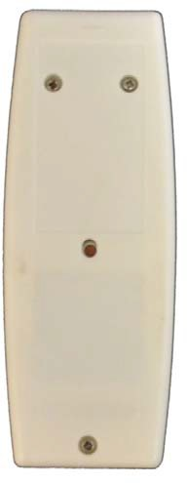

# Back of Remote

*\*\*NOTE: If the RED LED does not flicker in STEP 1, please remove the back of the remote and remove the battery from the remote. Press any button on the front a few times to clear the remote and reinstall the battery and try STEP 1 again.*

1. The RED LED light will flash 8 times and then shut off. The remote should now be paired to the control box. If pairing was successful, you will now be able to operate the lift with the wireless remote.