**Controlling SRV/ValueLine TV Lift System via 3rd Party RF Device**

**BroadLink Universal Remote**

***Items Needed:***

* One of the following SRV or ValueLine TV Lift Systems
  + 32800 – SRV 2800 TV Lift System
  + 33900 – SRV 3900 TV Lift System
  + 30003 – ValueLine 2800 TV Lift System
  + 30004 – ValueLine 3900 TV Lift System

- BroadLink Universal Remote System

https://www.ibroadlink.com/products/ir+rf

***Setup Instructions***

1. On the main page, click the + button to Add Remote

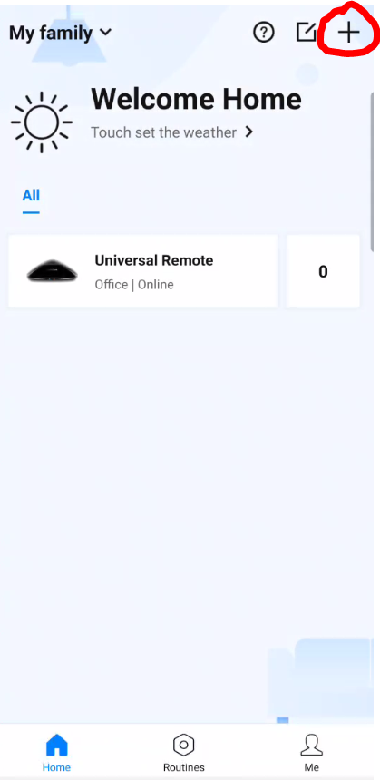 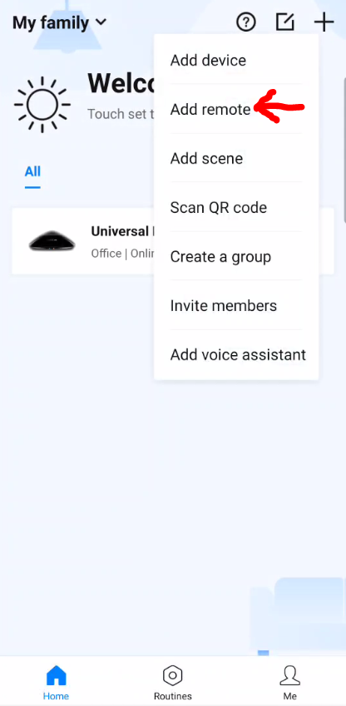

2. Click Universal Remote to add a new remote

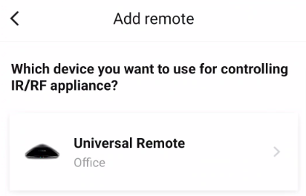

3. Click UserDefine remote control option.

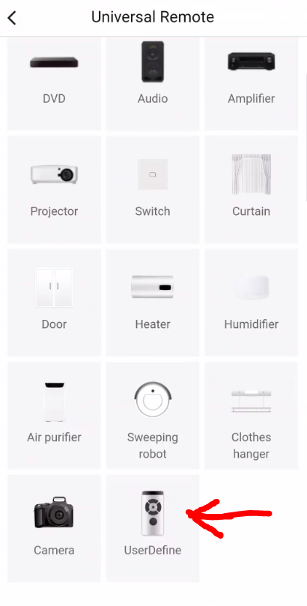

4. Click Add Appliance and select the location where the device will be located.

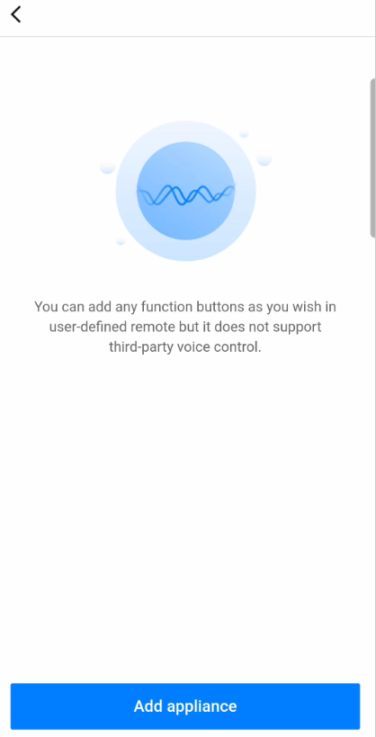 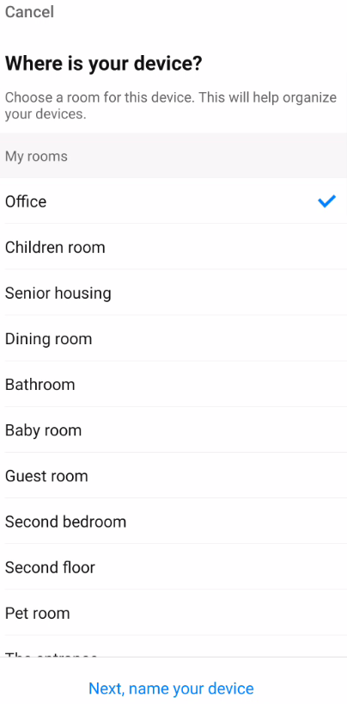

5. Name your device and click Save

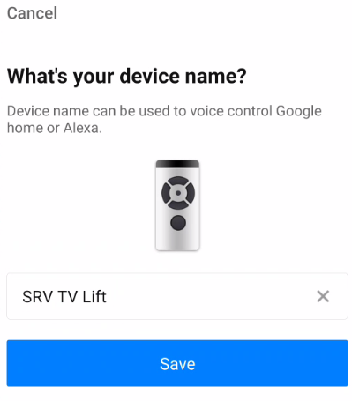

6. Click the I Know It button on the Tips for using sub device screen

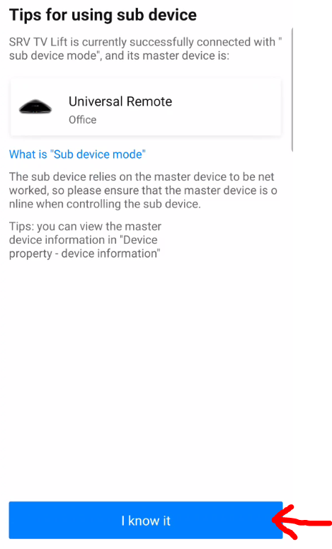

7. Click Use Device Now button

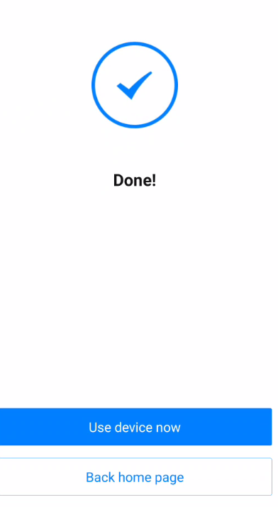

8. Next, buttons for the lift need to be added to the app. Click the Add functions buttons button to add functions.

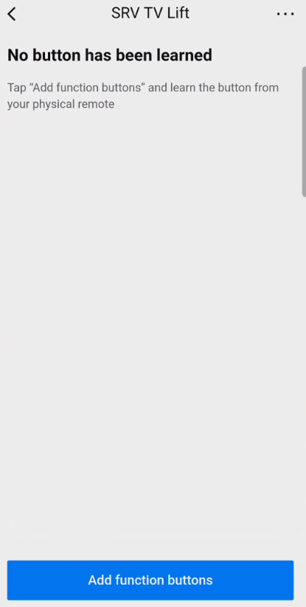

9. As the SRV/ValueLine wireless remote is a RF remote, select the RF Remote option to start pairing the remote buttons

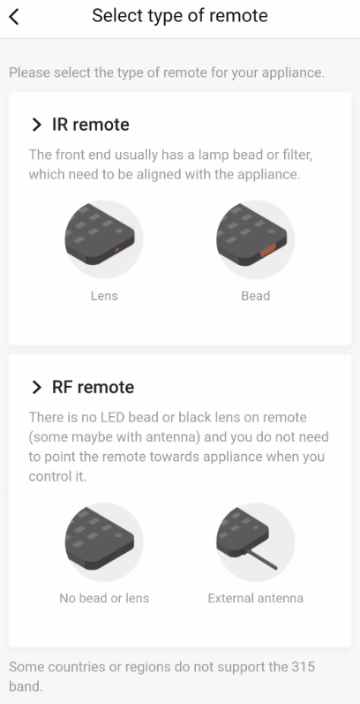

10. With your SRV/ValueLine TV Lift Wireless RF remote handy, click the Start Learning button in the app to teach the wireless remote buttons to the app.

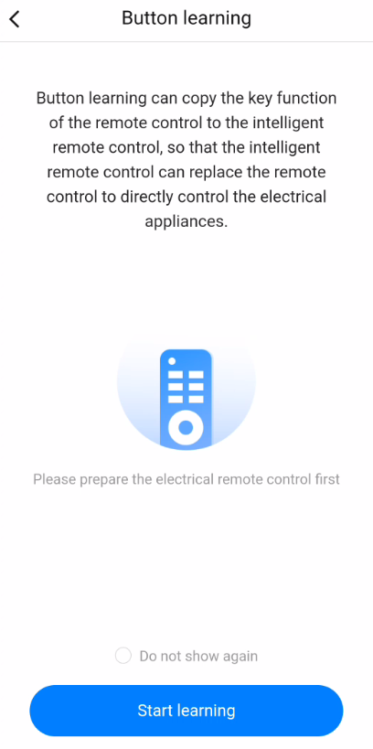

11. Click the Learn Simple RF Code option

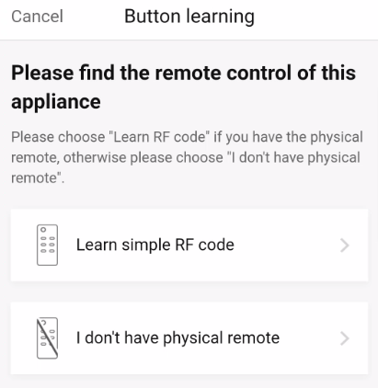

12. Follow the instructions in the app to start teaching each remote button to the app. Press and HOLD the any button on the SRV/ValueLine Wireless RF Remote to match the remote to the app. Once the Learning Successfully box pops up, click the Start Learning option.

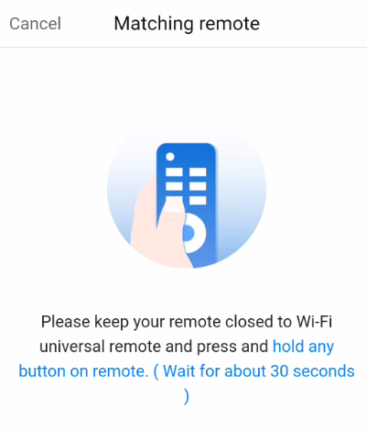 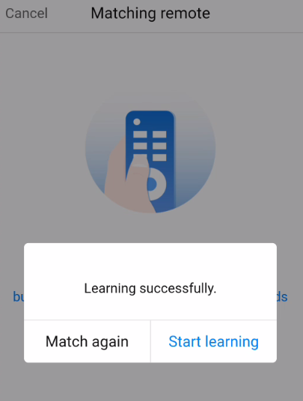

13. Once the Start Learning button is pressed, you have 30 seconds to pair a button on the SRV/ValueLine Wireless RF remote to the app. To pair the UP button, press the UP button on the SRV/ValueLine Wireless RF remote to pair the button to the app. Press the “clover” button in the app to test the function. The lift should go UP.

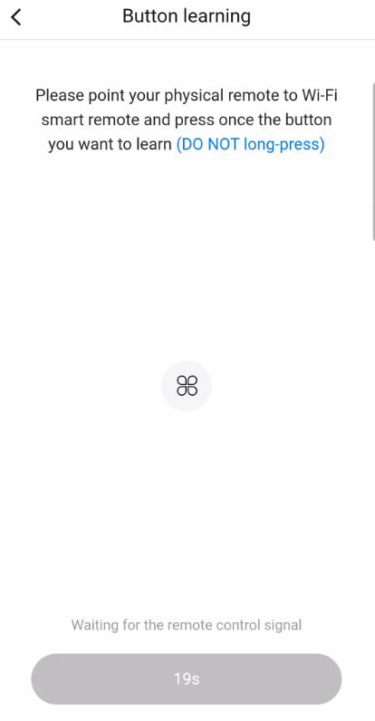 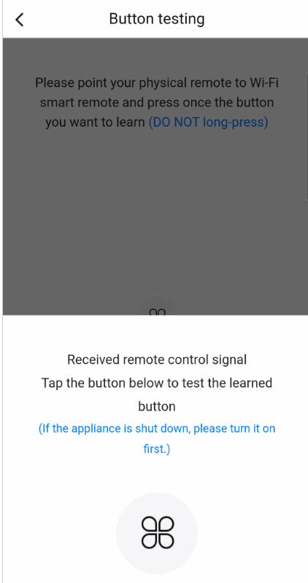

14. Once successful, answer YES that the device functioned properly when the button was tapped. On the Congratulations screen, click NEXT.

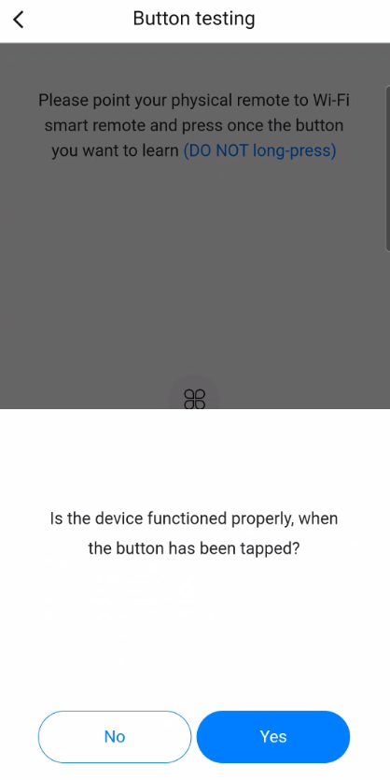 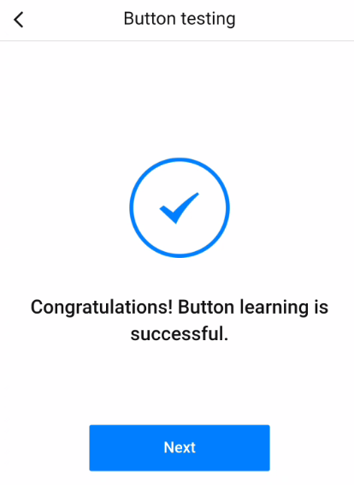

15. Name the button, in this case UP, and choose an icon for the button. Once finished click OK

|  |  |
| --- | --- |
|  |  |

16. The newly programmed button will now appear on the screen. To add the DOWN button, click the Add Function Buttons at the bottom of the app screen.

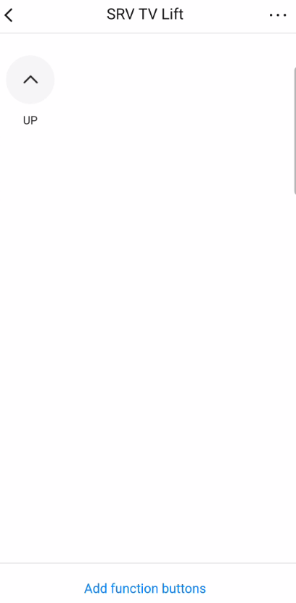

17. Follow steps 12-15 to add the DOWN button to the app. Once complete, you will now have both the UP and DOWN button on the app for the lift and can control the lift from the Broadlink app.

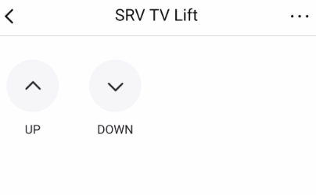

18. You can now control your SRV/ValueLine TV Lift through the BroadLink app.

**Please note, there may be up to a 3-5 second delay from when you press a button until when the lift performs that function. It is not recommended to use these functions in close quarters where something above or below the lift hinders the lifts travel.