**Installing Lift Extension Block – SRV and ValueLine TV Lifts**

***Tools Needed:***

* 4mm Hex Head Wrench
* 5mm Hex Head Wrench

***Instructions***

1. If the TV is already installed, remove the TV from the lift.
2. Once the TV is removed from the lift, remove the front place from the lift by removing the 4 hex head screws securing the front plate to the lift. Save the 4 hex head screws, as you will need them to resecure the front plate to the lift after installing the lift extension block.

|  |  |  |
| --- | --- | --- |
|  |  |  |
| a. 4 hex bolts on top of lift | b. remove bolts | c bolts removed |

1. Once the bolts are removed, remove the front plate from the lift.

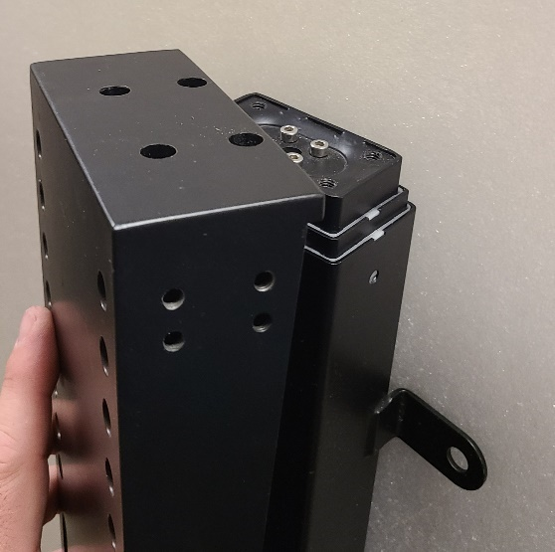 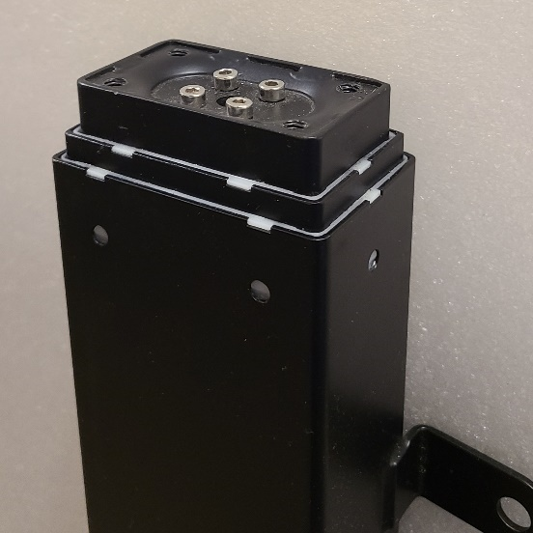

1. The lift extension block includes the following parts:

|  |  |
| --- | --- |
|  | - 1 lift extension block  - 4 4mm hex head screws – 15mm  - 5 4mm hex head screws - 10mm |

1. Remove the 2 hex head screws from the DOWN side of the lift extension block to release the DOWN side from the block.

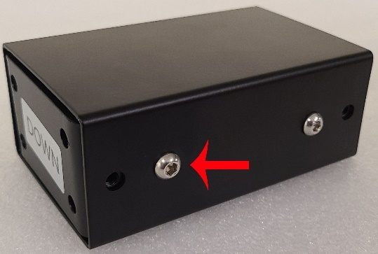 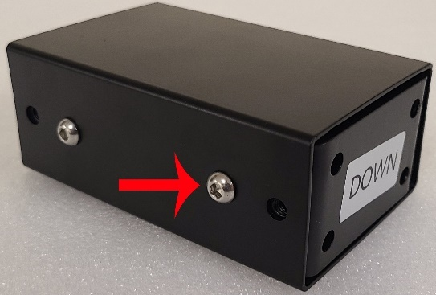

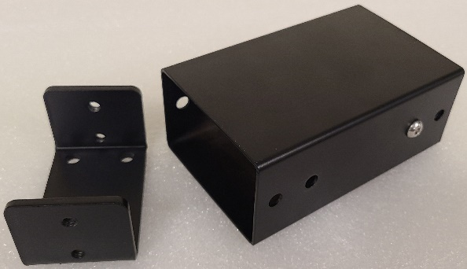

1. Once the DOWN side bracket of the extension block is removed, line the bracket up with the top of the lift and secure the bracket to the top of the lift using the 4 15mm hex head bolts.

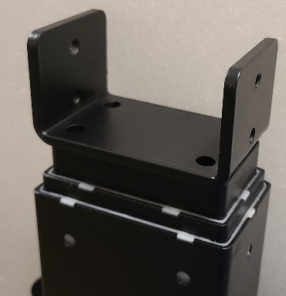 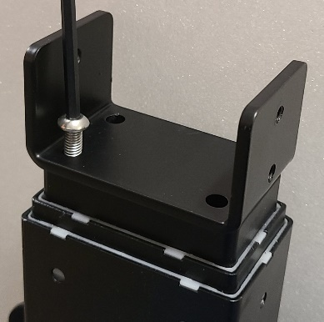 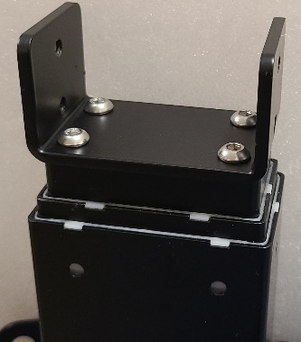

1. With the DOWN bracket attached to the lift, lower the lift extension block over the DOWN bracket and fasten with 2 10mm hex head bolts on each side, using the small hex head screws.

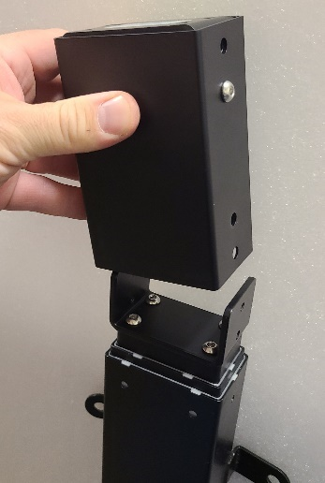 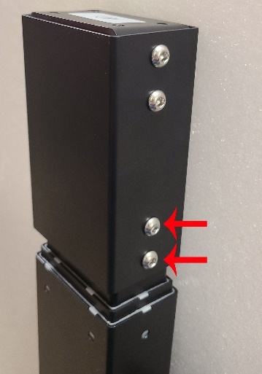 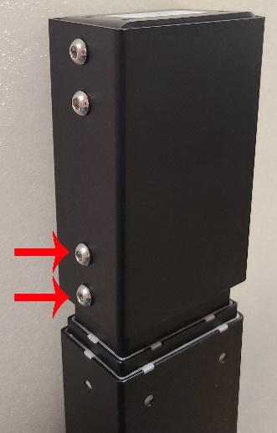

1. Once the lift extension block is secure, reinstall the front lift plate using the 4 5mm hex head bolts removed in step 2.

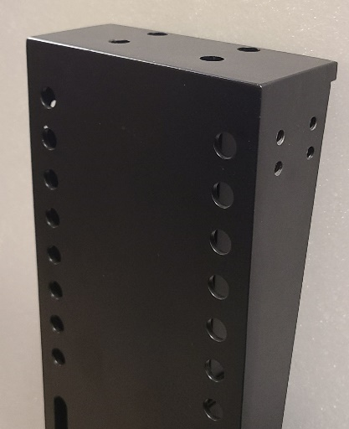 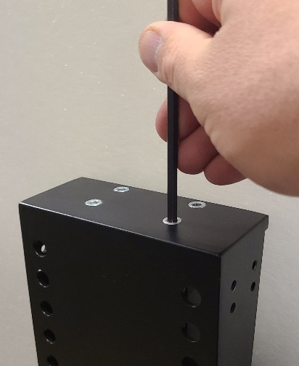 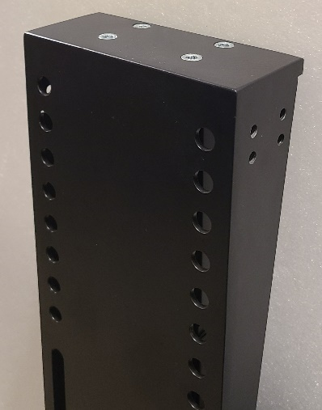

1. The top of the lift has now been extended to accommodate a taller TV. The maximum travel of the lift will not change, however, the starting point of the top of the lift is now 5” higher.

