Installing Roller Assembly and Lid Adapter Clips

For customers installing the ValueLine TV Lift in cabinets with hinged lids, an add-on roller assembly and lid adapter clips are available for purchase from Touchstone Home Products. The roller assembly and lid Adapter clip kit can be ordered by calling our customer service department at 800-215-1990 or through our website at www.touchstonehomeproucts.com

Parts Required:
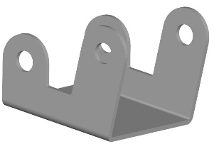  Roller Bracket | 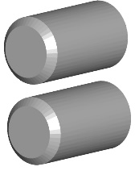  Rollers | 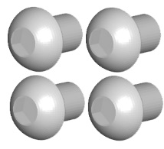  Roller Bolts
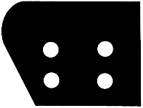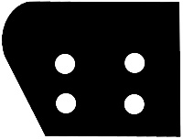  Lid Adapter Clips x2 | 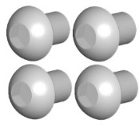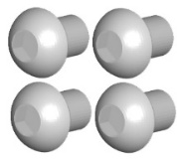  M6x16 Bolts (8 pieces) | 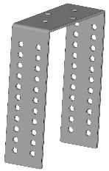  C Bracket

Tools Required:
- Hex wrench

Roller Assembly and Mounting Instructions:
1. Align the roller bracket with the 2 holes in the C bracket and attach the roller bracket to the C bracket using the bolts provided. | 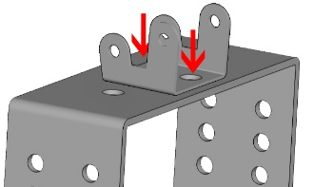
2. Once the roller bracket is attached to the C bracket, install both rollers on the roller bracket using the bolts provided.

Lid Adapter Clip and Roller Assembly Bracket Mounting Instructions:

1. Align the C bracket so that the roller is above the top of the TV.  **Please Note: The top of the TV should be lower than the roller assembly on top of the lift. The will insure that the roller is the first thing to come in contact with the lid when the lift goes up. | 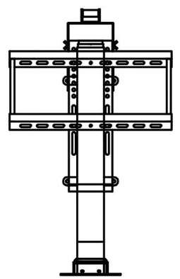
2. Align the Lid Adapter Clip with the corresponding mounting holes on the side of the C bracket and the lift column.  **Please Note: The rounded portion of the Lid Adapter Clip will be toward the top of the lift and face toward the back wall of the cabinet. | 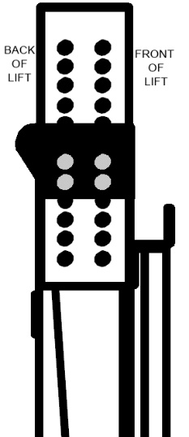
3. Using the provided M6x16 bolts, attach both Lid Adapter Clips to each side of the C bracket and lift. | 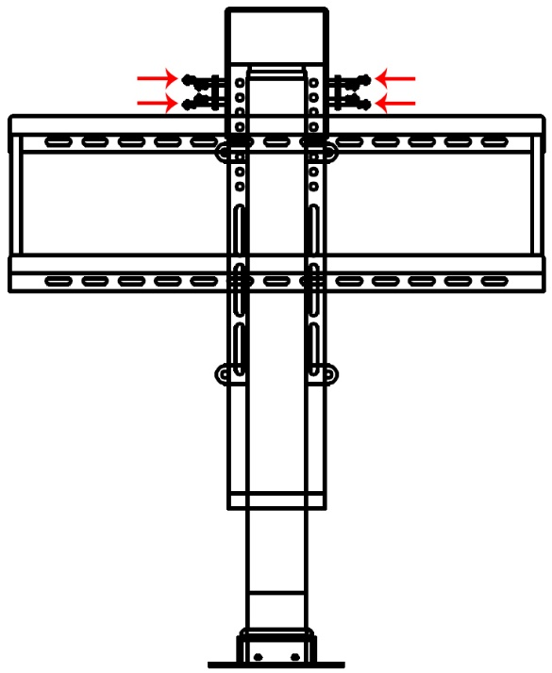

**If you have any questions regarding installation, please contact our support department at
800-215-1990 option 3

