**Replacing Motor on SRV/ValueLine TV Lift**

***Tools:***

- M4 allen key

- small flat head screwdriver

- Sharpie marker

***Instructions:***

1. Remove the lift from the cabinet, if not removed already.

2. Remove the 4 M4 screws holding the base plate to the bottom of the lift. Save the screws for re-installation later.

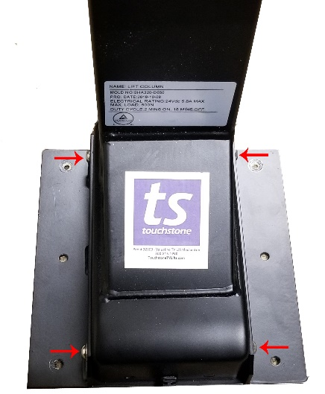 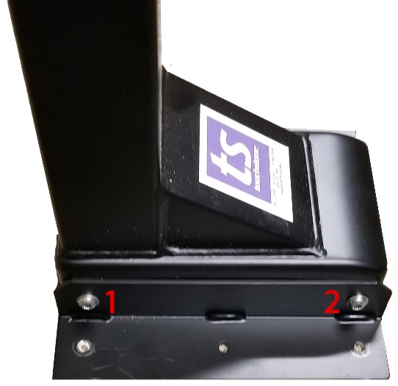 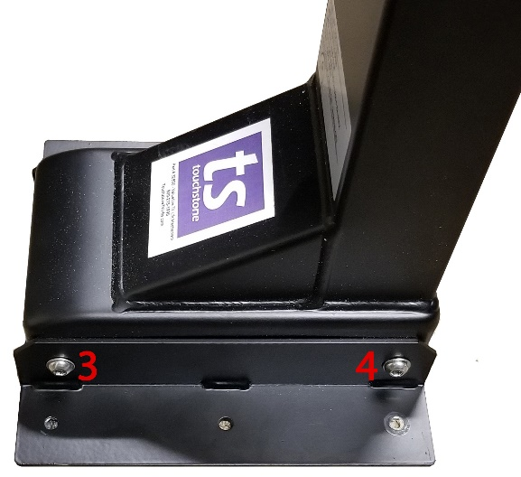

3. Once the base plate is removed, turn the lift over to access the bottom of the lift.

4. Remove the cover on the bottom of the lift. To release the cover, pop the tabs around the base of the lift. Insert a small flat head screwdriver into the hole and push the clip in and upwards.

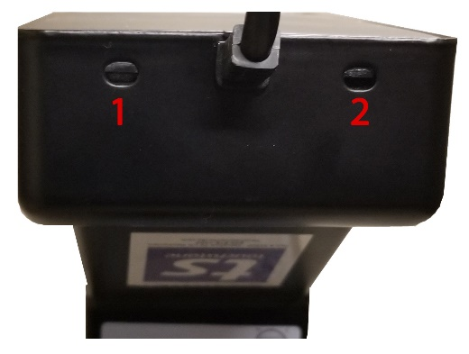 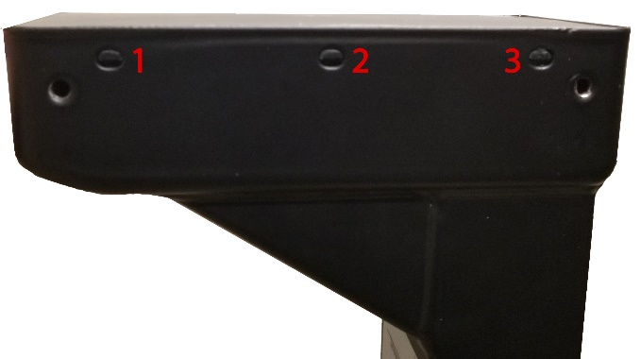

Front of Lift Left Side of Lift

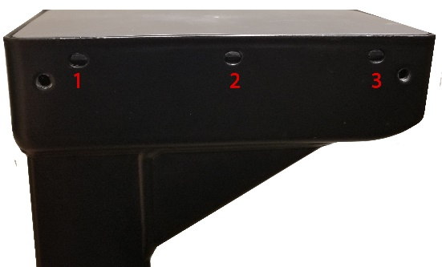 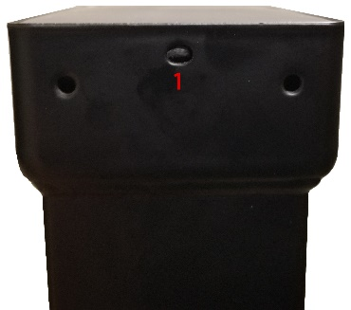

Right Side of Lift Back of Lift

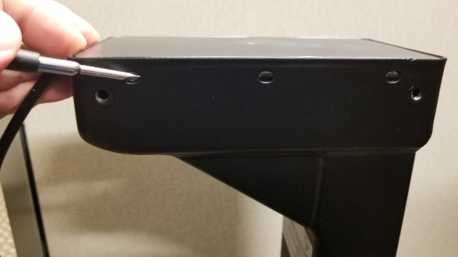 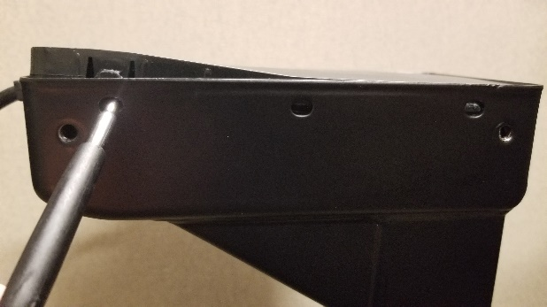

5. Once the cover is removed, you will have access to the motor in the base of the lift.

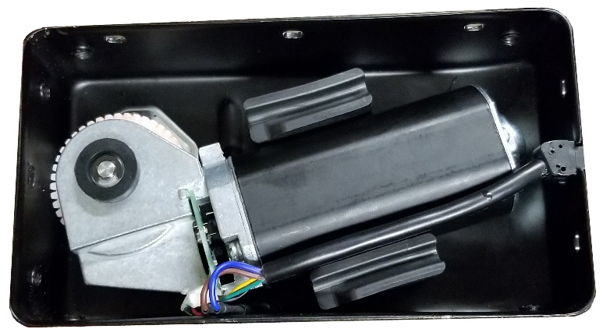

6. Remove the defective lift from the lift assembly.

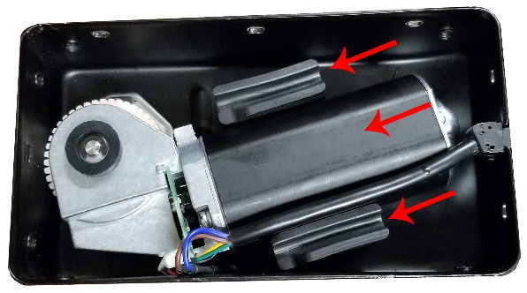 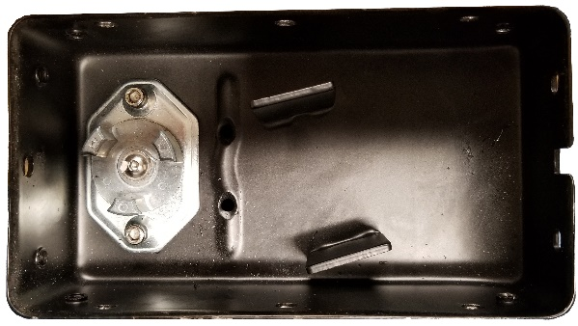

7. Make a tic-mark on the new motor as show below. This will line up with the studs on the lift mount.

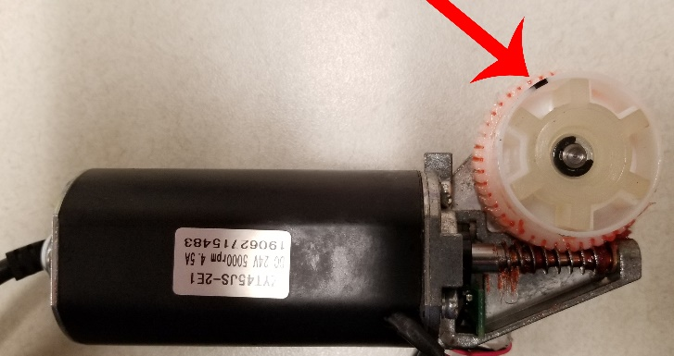 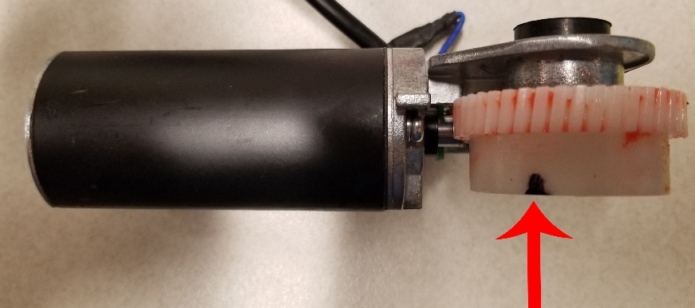

8. To install the new motor, line the notch on the motor gear up with the motor mount studs in the lift.

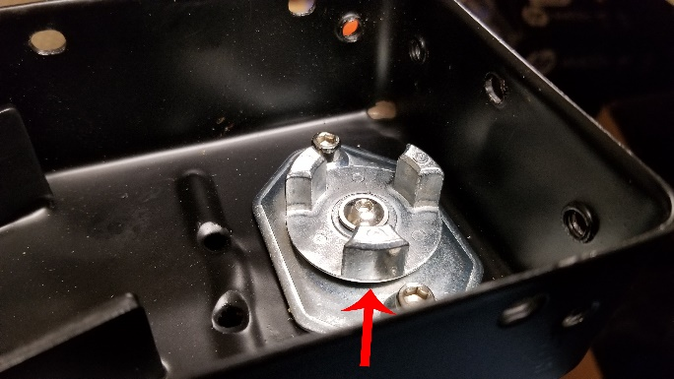 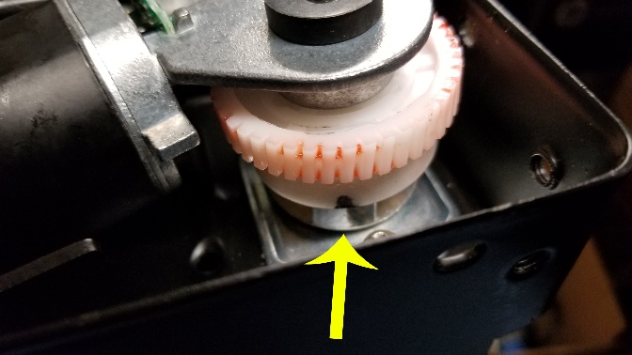

9. Once the new motor is installed, reinstall the 2 pads to hold the motor in place.

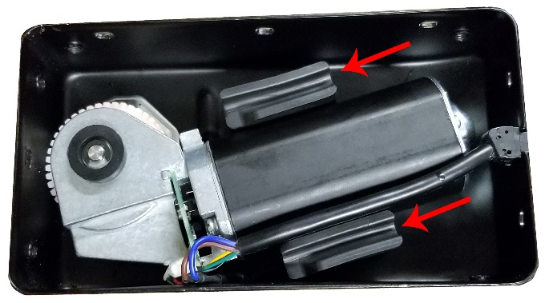

10. Once the motor is installed, the cover of the base of the lift needs to be modified so that the cover fits with the new motor. Clip part of the side wall of the base shown below.

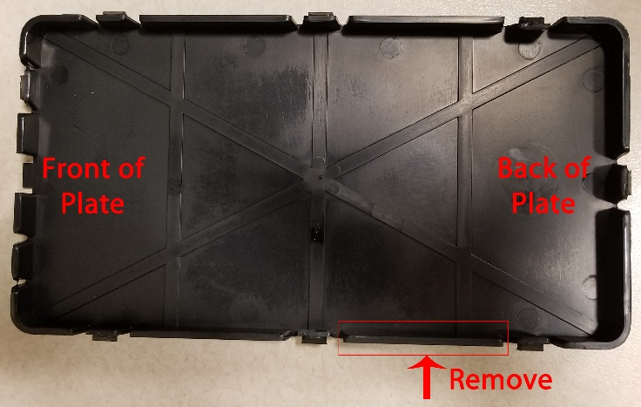 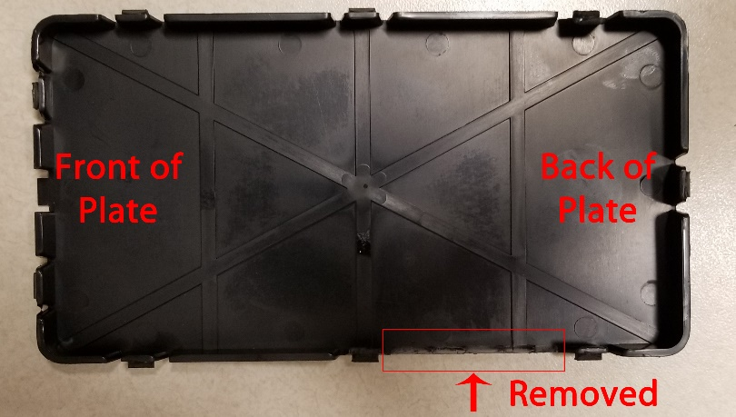

11. Once the base cover is modified, reinstall the base cover.

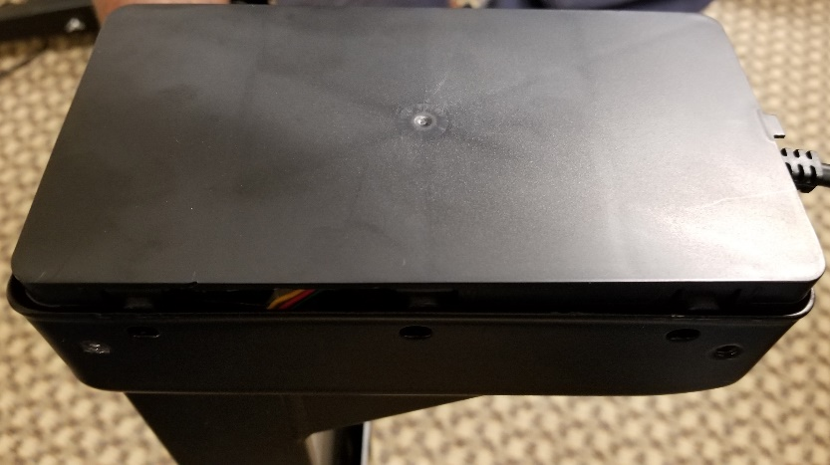

12. Once the base cover is installed, test the lift. Run the reset procedure, if necessary.

13. Once replacement is complete, reinstall the metal base plate to the lift that was removed in step 2.